Data Subject Rights Request Form

Date______________
According to the Personal Data Protection Act B.E. 2562 (2019) (“PDPA”), a data subject and personal data owner is entitled to the rights of access and processes of his/her personal data under the supervision of Kata Group and Beyond Resorts. As the data subject and personal data owner you may exercise this right by providing Kata Group and Beyond Resorts with the below request form at oda-brkt@katagroup.com Tel: (+66) 076 360300
Details of the applicant
Name-Surname  ID card number or passport number  Contact number  E-mail address | ____________________________________________________  ____________________________________________________  ____________________________________________________  ____________________________________________________
If the applicant is a representative of the personal data subject.
(Please specify the details of the owner of the information)
Name-Surname of data owner  ID card number or passport number | ____________________________________________________  ____________________________________________________
Your right to request | Your request details
Right to access/request a copy  Right to be informed  Right to correct information  Right to transfer data  Right to object  Right to suspend the use of information  Right to withdraw consent  Right to erasure  Right to file a complaint | __________________________________________________________________________________________________________________  _________________________________________________________  _________________________________________________________  _________________________________________________________  _________________________________________________________  _________________________________________________________  _________________________________________________________  _________________________________________________________

Information in this document will only be used to process your request to exercise your personal data rights. You can read our “Privacy Policy” by scanning QR Code.
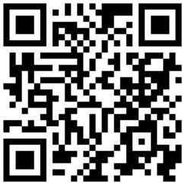
Sign …….................................. The person applying for the exercise of rights
(…………………………….……………….)

